# IoT Based Air Pollution Monitoring System

A Project report submitted in partial fulfilment of the requirements for the degree of B.Tech Information Technology

By,

M.ROSHINI (513221205016)

Under the supervision of

Professor & HOD

Department of Information Technology

# AIR QUALITY MONITORINH SYSTEM:

## PHASE 4: DEVELOPMENT PART – 2

Atmospheric conditions continue to deteriorate each year due to the growth of civilization and increasing unclean emissions from industries and automobiles. Although air is an indispensable resource for life, many people are indifferent to the severity of air pollution or have only recently recognized the problem [1–3]. Among various types of pollutants such as water, soil, thermal, and noise, air pollution is the most dangerous and severe, causing climate change and life-threatening diseases. According to the World Health Organization (WHO), 90 percent of the population now breathes polluted air, and air pollution is the cause of death for 7 million people every year [4, 5]. The health effects of pollution are very severe that causes stroke, lung cancer, and heart disease. Furthermore, air pollutants have a negative impact on humans and the earth’s ecosystem, as observed in recent global air pollution problems like ozone depletion [6–8]. Therefore, air quality monitoring and management are main subjects of concern.

According to the United States Environmental Protection Agency (EPA), indoor air is 100 times more contaminated than outside air. Most modern populations spend 80 to 90 percent of their time indoors; therefore, indoor air has a greater direct impact on human health than outside air [9–12]. Moreover, in contrast to atmospheric pollution, indoor pollutants are about 1000 times more likely to be transmitted to the lungs, causing diseases such as sick building syndrome, multiple chemical sensitivities, and dizziness. Indoor air quality management is very important, as it can prevent exposure through proactive precautionary measures [9, 13–15]. Therefore, efficient and effective monitoring of indoor air is necessary to properly manage air quality

### Abstract:

IoT-based indoor air quality monitoring platform, consisting of an air quality-sensing device called “Smart-Air” and a web server, is demonstrated. This platform relies on an IoT and a cloud computing technology to monitor indoor air quality in anywhere and anytime. Smart-Air has been developed based on the IoT technology to efficiently monitor the air quality and transmit the data to a web server via LTE in real time. The device is composed of a microcontroller, pollutant detection sensors, and LTE modem. In the research, the device was designed to measure a concentration of aerosol, VOC, CO, CO2, and temperature-humidity to monitor the air quality. Then, the device was successfully tested for reliability by following the prescribed procedure from the Ministry of Environment, Korea. Also, cloud computing has been integrated into a web server for analyzing the data from the device to classify and visualize indoor air quality according to the standards from the Ministry.

* We propose the use of the Smart-Air for the precise monitoring of indoor air quality
* We propose the utilization of an IoT for efficient monitoring of real-time data
* We propose the adoption of cloud computing for real-time analysis of indoor air quality
* We originally developed a mobile application to make the proposed IoT system with features of anytime, anywhere (v)The device has been tested for reliability of the data and the platform has been implemented in a building to test its feasibility

### Smart-Air

An accurate data measurement of indoor air quality is the most important factor for the platform. Thus, Smart-Air was developed to collect accurate and reliable data for indoor air quality monitoring. Because the monitoring area is not constant, the device was designed to be easily customized to an environment by using an expandable interface. Thus, various types of sensors can be installed or adjusted based on the environment. Also, a Long-Term Evolution (LTE) modem is mounted in the device to transmit detected data directly to the web server for classifying and visualizing air quality. For most IoT platforms, gateway or data loggers are installed to gather and transmit data wirelessly to the web server. However, in this study, a microcontroller was installed in the device to gather the data from the sensors and transmit it to the web server using the LTE modem, eliminating the need for a gateway and a data logger.

The most important purpose of Smart-Air is to precisely detect air quality in the perception layer of the platform that a primitive concept design of the device is shown in Figure [1.](https://www.hindawi.com/journals/js/2020/8749764/fig1/) This device has an expandable interface such that multiple sensors can be installed simultaneously or easily added according to monitoring requirements. In the present study, the Smart-Air device consists of a laser dust sensor, a volatile organic compound (VOC) sensor, a carbon monoxide (CO) sensor, a carbon dioxide (CO2) sensor, and a temperature-humidity sensor.

Moreover, an LED strip was installed in the center of the device to visualize air quality using colors. When the quality of air changes, the device’s LED changes color and wirelessly sends an alert message to the web server via LTE. Thus, the LTE modem transmits and receives data by communicating with the web server for detailed monitoring and determination of air quality as the presentation layer of the platform.

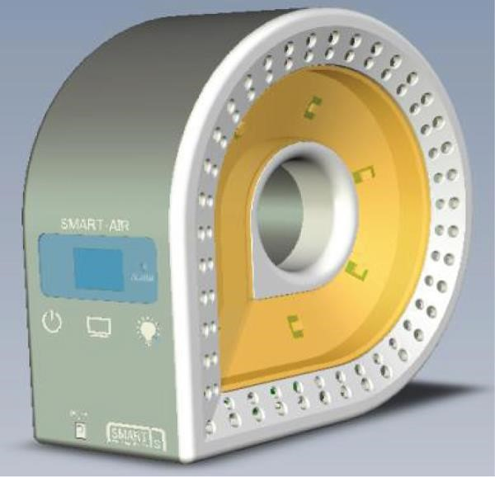

Microcontroller

The microcontroller is a compact integrated circuit used as an embedded system by receiving input from multiple sensors. In this paper, STM 32 F407IG from STMicroelectronics was selected, since it is designed for high performance and integration. The core of the microcontroller is the ARM 32-bit Coretex-M4 CPU that incorporates high-speed embedded memory. Table [1](https://www.hindawi.com/journals/js/2020/8749764/tab1/) summarizes the specifications of the STM 32 F4071G microcontroller [26]

### VOC Sensor

The VOC sensor used in the study was selected based on an investigation by the Ministry of Environment, Korea. The sensor is a semiconductor type that can have a small diffusion effect and requires data verification. Accordingly, calibration and a chamber test were conducted to test the reliability of the VOC sensor. To calibrate the sensor, Smart-Air was placed in an acrylic chamber with a PID-type VOC sensor, i.e., MiniRAE 3000 from RAE Systems. The PID type VOC sensor was the most accurate and reliable type to detect VOCs. After the sensors were placed, about 1 inch of incense was burned to create a VOC compound to measure.

